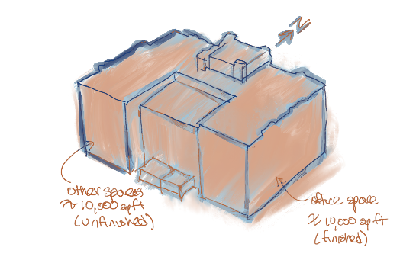

Inspek LLC

Your Address

Andover, MA, 01876

Phone Number

{clientName}

{mailingAddress}

{propertyName}

{propertyAddress}

{Date}

# Subject: Proposal for Commercial Property Inspection Services

Dear Kristjana Xhuveli,

Welcome to Inspek, where excellence meets expertise in commercial property inspections. With our unparalleled commitment to accuracy and client satisfaction, we are the trusted choice for your inspection needs.

At Inspek, we understand the importance of making informed investment decisions. Our team of skilled professionals combines technical proficiency with practical insights to provide comprehensive and reliable inspection services. You might be asking yourselves what sets us apart from the competition? It's our unwavering dedication to meet your specific needs so that ultimately *you* can succeed. We go above and beyond to deliver precise and actionable reports, empowering you with the knowledge to make confident investment choices.

With Inspek, you'll experience a seamless and professional process from start to finish. Our transparent communication and personalized approach ensure that your needs are heard and met every step of the way.

Select Inspek as your trusted partner for commercial property inspections and experience the confidence that comes with thorough knowledge and expert guidance. Let us exceed your expectations and establish a lasting partnership based on trust, reliability, and exceptional service.

Attached you will find our proposal for your property inspection located at . If you have any questions, please don’t hesitate to ask us by contacting 603-892-1249. Your success is our number one priority, and we thank you for your interest in our partnership.

Kristijan Djulabic CEO

Inspek LLC.

**Property Description:**

The commercial property to be inspected is located at . The building is a {propertyType} with a total footprint of approximately {totalBuildingSqFt}. It consists of various spaces, including:

{manufacturingSpacePercentage}

The building is constructed with {structuralSystems} *[Specify the known structural characteristics, such as masonry, frame, steel, stucco, etc.]*.

Distinguishable features of the commercial property include {uniqueProperties} *[Specify any unique or notable features of the property, such as architectural elements, specialized equipment, historical significance, etc.]*. These features add to the property's character and may require additional attention during the inspection process.

**Scope:**

Inspek's comprehensive commercial inspection focuses on the façade and roof components of the subject property located at . Our certified team of experienced inspectors conduct a non-destructive visual examination of the property’s readily accessible areas, documenting our findings along the way. The inspection includes a thorough review of roofing components, such as the membrane, flashings, drainage systems, and other relevant components [but not/ including] HVAC [and/or] Electrical units themselves [unless otherwise specified]. We also evaluate the façade components, including cladding, windows, doors, masonry, and exterior finishes, for potential areas of concern and water intrusion.

Our {typeOfInspection} *Inspection* report provides a detailed analysis of the property's building envelope condition, supported by photographs, descriptions, and remediation recommendations. We compare the façade's condition to similar properties in the area, considering factors like age and location. Based on our evaluation, we provide a comprehensive list of recommended repairs and maintenance items that are essential for the effective and efficient functioning of the façades and roofing components.

Please note that our {typeOfInspection} *PCR Inspection* is limited to accessible areas and involves visual observations only and is not “technically exhaustive”. The report highlights any limitations or exclusions associated with the inspection. Our objective is to equip clients with a reliable and professional report that empowers them to make informed decisions about their property. We strive to provide peace of mind by identifying and prioritizing necessary repairs and maintenance.

**Services:**

Inspek will perform a comprehensive inspection of the commercial property as described above. Our inspection will cover the major components and systems of the property, including but not limited to:

* Exterior Building Components and Systems
* Roofing System (Non-HVAC/ Electrical units)
* Electrical, Fire, and Life Safety Systems
* HVAC System
* Plumbing System
* Accessibility Compliance
* Environmental Concerns (optional, if requested)

Our inspection will adhere to the standards and guidelines set forth by the Certified Commercial Property Inspectors Association (CCPIA) and will be conducted by our qualified and experienced commercial property inspection professionals.

The detailed breakdown of our services, including the specific components and systems to be inspected, will be outlined in the Inspection Agreement and Scope of Work document provided upon acceptance of this proposal.

**Fees & Retainers:**

The fee for the commercial property inspection is based on the scope of work and requested services by the client. Documentation of observations and findings, review of relevant documentation and maintenance records, the evaluation of the property’s condition, and recommendations for remediation are included as part of the total inspection fee.

Our pricing model is based on several key factors, including the total facade square footage to be inspected, the number of building elevations, and the complexity of the project. Our tiered pricing structure ensures that you receive fair and competitive rates tailored to the specific needs of your property. Detailed pricing breakdowns are available upon request.

The following breakdown outlines the associated fees based on the scope of work for the property located at .

|  |  |  |
| --- | --- | --- |
| Breakdown | |  |
| Façade | **$6,000+** |  |
| Roofing System (Minus MEP) | **$3,000+** |  |
| HVAC System | **$X,XXX** |  |
| Plumbing | **$X,XXX** |  |
| Electrical, Fire, and Life Safety | **$X,XXX** |  |
| Fire & Life Safety | **$X,XXX** |  |
| Accessibility compliance | **$X,XXX** |  |
| Additional Services | |  |
| Preliminary Inspection Report | **$350/ Building System** |  |
| Specialty Testing | **$X,XXX** |  |
| Environmental Concerns | **$X,XXX** |  |
| Follow-up Consultation | **$200/ Hour** |  |

**Commercial Property Inspection: $X,XXX**

**Payment Terms:**  
A non-refundable retainer fee of 50% of the total inspection fee is due upon scheduling the inspection. This retainer confirms the inspection date and allows for necessary preparations.

The remaining balance is due **before the final inspection report is delivered**. Once the balance is paid in full, the report and all associated deliverables will be promptly sent to the client.

For larger, multi-phase projects, alternative payment schedules can be arranged and agreed upon in writing before the project begins.

Please note that all fees are subject to applicable taxes.

Timeframe:

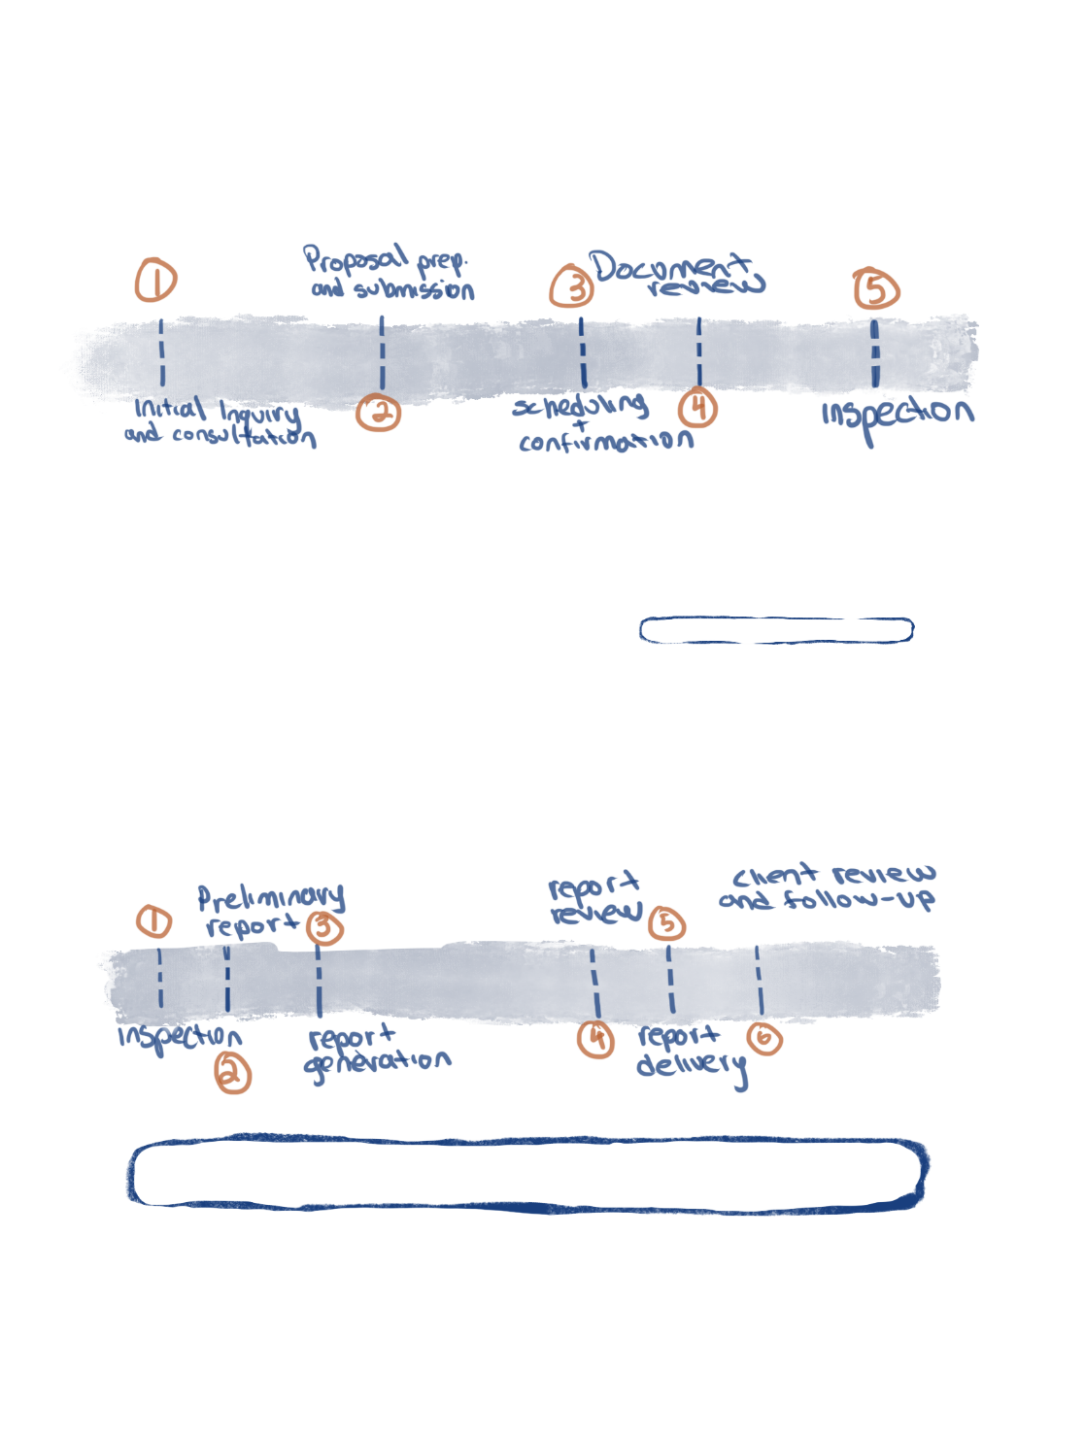Inspek is committed to providing timely and efficient delivery of inspection reports to our clients. The following outlines the estimated time frames for the completion and delivery of the inspection reports, taking into consideration the involvement of sub-contractors for specialized inspections:

*Pre-Inspection*

*Post-Inspection*

Preliminary Report:

Within 72 hours after the on-site inspection, an initial summary report will be provided. This report will highlight the key findings and urgent matters identified during the inspection.

Comprehensive Inspection Report:

The comprehensive building envelope inspection report will be delivered 7-14 business days after the completion of the on-site inspection depending on complexity. This report will provide a detailed assessment of the commercial property’s major systems and components as part of the agreed upon scope of work determined by the client and Inspek.

Subcontractor Reports:

If subcontractors are involved in conducting specialized inspections (e.g., mechanical, electrical, plumbing, etc.), their respective reports will be provided as soon as they are available. The time frame for these reports may vary depending on the nature and complexity of the inspections. We will coordinate with the subcontractors to ensure their reports are incorporated into the final comprehensive inspection report.

Please note that the above time frames are estimates and may be subject to change based on the size and complexity of the commercial property, accessibility to all areas, and any unforeseen circumstances that may arise during the inspection process. We strive to deliver accurate and comprehensive reports within the specified time frames to meet your needs and expectations.

In the event of any delays or changes to the delivery schedule, we will promptly communicate with you and provide updates on the revised time frames.

We understand the importance of timely access to inspection reports for informed decision-making and are committed to ensuring that you receive the final reports in a timely manner.

**Client Acceptance:**

To proceed with our commercial property inspection services, we kindly request your acceptance of the proposal outlined above. By accepting this proposal, Kristjana Xhuveli acknowledges and agrees to the terms, conditions, and fees specified herein. This acceptance will serve as a binding agreement between Inspek and Kristjana Xhuveli (hereafter referred to as 'Client').

Acceptance of the proposal indicates your understanding and agreement to the following:

Scope of Work:

You have reviewed and approved the scope of work outlined in the proposal. This includes the specific areas, components, and systems to be inspected, as well as any additional services or specialty inspections requested.

Fee Structure and Payment Terms:

You understand and agree to the fee structure as detailed in the proposal. The payment terms, including any required retainer or deposit, invoice issuance, and payment due dates, have been clearly specified. All payments shall be made in accordance with the agreed-upon terms.

Time Frame for Delivery:

You acknowledge that the inspection report will be delivered within the agreed-upon time frame following the completion of the on-site inspection. This allows for the compilation, analysis, and generation of a comprehensive report based on the findings.

Subcontractors and Specialists:

You understand that, if applicable, certain aspects of the inspection may be carried out by qualified subcontractors or specialists. Their involvement ensures a thorough evaluation of specific systems, such as mechanical, electrical, or plumbing components.

Limitations and Exclusions:

You have reviewed and accepted any limitations or exclusions associated with the inspection, as described in the proposal and accompanying documentation. These limitations define the extent of the inspection and highlight any areas that may not be fully accessible or covered by the inspection.

Please indicate your acceptance of this proposal by signing and returning a copy to Inspek. Upon receipt of your acceptance, we will schedule the commercial property inspection and begin the necessary preparations to provide you with a comprehensive and professional inspection service.

We appreciate your consideration and look forward to working with you to ensure that your commercial property inspection meets the highest standards of quality, accuracy, and professionalism.

Inspek LLC

Kristijan Djulabic

[Date]

Client Acceptance:

This agreement is signed on behalf of Kristjana Xhuveli by , {roleOrRelationship}.

I, Kristjana Xhuveli, hereby acknowledge and accept the terms and conditions outlined in this proposal for commercial property inspection services provided by Inspek. I understand that my acceptance signifies a binding agreement between Inspek and myself, and I agree to fulfill the responsibilities outlined in this proposal.

Signature: ________________________________________

Printed Name: ____________________________________

Date: _____________________________________________

---------------------------------------------------

Signature: ________________________________________

Printed Name: ____________________________________

Date: _____________________________________________